Project title: Smart Financial Analyzer
Steven Wenfeng Xiong
Nikolaos Karigiannis
Rishi Bhattacharyya

Disciplines:
· Math (Calculus + Probability and Statistics)
· Computer Science
Project type: Design
Abstract
Personal budgeting can be hard to manage, especially for those that use static averages and ignore the variability of monthly expenses, which can cause people to be unprepared to handle fluctuations in their finances. Students are an extremely vulnerable demographic when it comes to budgeting. This is why we developed a Python-based program that can analyze spending data and provide probabilistic risk assessments for future spending. Users input their data in an excel file, and the program separates expenses into different categories, such as needs, wants or savings, computes statistics such as mean, standard deviation, and variance, and uses derivatives and integrals to identify spending trends and cumulative totals. It also uses a Monte Carlo simulation that takes random monthly spending numbers from normal distributions based on the users' spending data and then simulates thousands of possible future spending outcomes over a specific period. The output provides users with the average, minimum, and maximum spending, along with a histogram of the simulated outcomes and a warning when the spending exceeds or approaches the budget. Additional visualizations include category bar charts and time-series plots. This financial tool takes uncertainty into account, allowing users to consider future risks. This program displays the probabilistic risk in financial budgeting and provides a tool for students to manage their finances.
Objective
The core objective of this project is to develop a Python-based program that allows users to input and analyze personal financial data, categorize transactions, and evaluate spending behavior relative to a defined budget. The program makes use of fundamental concepts of calculus and probability to model spending trends, detect increases in spending, and provide possible future financial outcomes.
Introduction
In modern society, financial decision-making has become increasingly complex. Individuals are exposed to constant streams of consumption opportunities, subscription-based services, digital transactions, and fluctuating economic conditions. As a result, understanding and predicting personal spending behavior has become both a practical necessity and a subject of quantitative study. University students are a demographic that could especially benefit from this project, considering that they represent a significant consumer group with distinct spending patterns and credit use behaviors (1). Financial forecasting, traditionally applied in macroeconomics and actuarial science, relies heavily on mathematical modeling and probabilistic analysis to anticipate future trends. As emphasized by Robert C. Merton (1994), mathematical models have transformed finance from a descriptive discipline into a quantitatively driven field in which uncertainty, risk, and time are analyzed using formal probabilistic frameworks (2). However, similar quantitative tools can also be adapted to the micro-level of personal finance.
Spending behavior over time can be conceptualized as a dynamic system influenced by both deterministic trends and stochastic (random) variability. In quantitative finance and econometrics, time-dependent financial data are often modeled using time-series analysis, where variables evolve over time under the influence of underlying patterns and random fluctuations (3). Inspired by this framework, this project aims to construct a simplified yet mathematically rigorous computational model of personal expenditure behavior using real financial data.
At its core, this project treats individual spending as a function of time, S(t), where t represents discrete days. Although financial transactions occur at discrete intervals, concepts from calculus provide valuable analytical insight. The derivative, S′(t), represents the rate of change of spending over time, allowing the identification of increasing or decreasing expenditure trends. Large positive changes in this rate may indicate sudden increases in spending, while negative changes suggest reductions or stabilization. Similarly, the cumulative sum of spending values serves as a numerical approximation of a definite integral, providing total expenditure over a given time interval. This allows for tracking overall financial behavior and comparing it to a predefined budget.
However, deterministic trend analysis alone does not fully capture real financial behavior. Empirical research in behavioral economics demonstrates that spending patterns are influenced by impulsive decisions, income timing, unexpected expenses, and psychological biases. For example, Berman et al. (2016) show that individuals tend to underestimate future expenses when forecasting their finances, a phenomenon known as expense neglect (4). This highlights the importance of incorporating uncertainty into financial modeling rather than relying solely on deterministic predictions.
To address this, the project incorporates statistical modeling and probabilistic simulation. Spending amounts are treated as random variables, and key statistical measures such as the mean, variance, and standard deviation are calculated from observed data. The Central Limit Theorem states that the distribution of a normalized sample mean converges to a standard normal distribution. Under the Central Limit Theorem, aggregated spending can often be approximated using a normal distribution, allowing for probabilistic interpretation of future outcomes. These statistical properties are then used in a Monte Carlo simulation framework, where repeated random sampling generates thousands of possible future spending scenarios (5). As described by Kritzman (1993), such stochastic methods produce a distribution of outcomes rather than a single prediction, enabling estimation of the probability of exceeding a given budget (6).
Unlike traditional budgeting tools that primarily track past expenses, this project emphasizes predictive analysis and behavioral insight. By combining deterministic trend analysis with probabilistic simulation, the model provides both an explanation of past spending patterns and an estimation of future financial outcomes.
Overall, this project demonstrates how concepts from calculus, probability, and computer science can be integrated into a practical computational system for analyzing personal financial behavior. It highlights the relevance of mathematical modeling in everyday decision-making and illustrates how theoretical tools can be applied to real-world data to generate meaningful insights.
Methods
The computational implementation of this model was carried out in Python, making use of the pandas library for data manipulation, NumPy for numerical computation, and Matplotlib to visualize the results. The main functions of the program include data preprocessing, categorizing expenses, descriptive statistical analysis, time-series and calculus based analysis, and a Monte Carlo simulation.
Data Preprocessing
The financial transaction data is given by the user in a Microsoft Excel document, which contains the financial data split into different categories defined by the user. The program reads all the sheets using the pd.read_excel function and then merges them into a single DataFrame. After this, all expense values were converted into absolute values to not interfere with mathematical operations that happen later. Rows with missing values in the “Amount” or “Description” columns were dropped. All of the “Amount” values were converted into numbers, with the non-numerical values being listed as NaN and being disregarded. The “Description” column was turned into lower case so that it could match the keywords in the dictionary. The “Date” column was converted into datetime format and rows with invalid dates were removed.
Transaction Categorization
Each transaction was assigned to one of four categories, which are Income, Needs, Wants, and Savings. This was done by matching keywords with a predefined dictionary. For each transaction the description was scanned for keywords that are included in the categories and the category was assigned to it. If no keywords match with the dictionary, the transaction is labeled as Uncategorized. The dictionary is editable, which allows users to add keywords that they may deem necessary for the program to properly analyze their financial data.
Category | Keyword
Income | income, salary, allowance
Needs | rent, bills, utilities, food, groceries, transport, insurance
Wants | shopping, entertainment, restaurants, movies, subscriptions
Savings | savings, investment
Table 1: Default keyword dictionary used for transaction categorization
Descriptive Statistical Analysis
Three primary descriptive statistics were computed using the transaction amounts that were organized in the data preprocessing and transaction categorization. The mean was calculated as the average of all transaction amounts, the variance was calculated as the average of the squared deviations from the mean, and the standard deviation was taken as the positive square root of the variance. These statistics were computed using the .mean, .std, and .var functions. These are used later as parameters for the Monte Carlo simulation.
Budget and Behavioral Analysis
For the time-series analysis, the expenses were sorted by date and aggregated into daily time series by adding all of the transaction amounts on each day. This provided a sequence of daily expenses sorted by date.
The model evaluates financial behaviour using both cumulative spending and the rate of change in spending over time. First, the cumulative spending is computed and the final value is extracted using final_spending = cumulative.iloc[-1], which represents the total expenditure at the end of the observed time period. This value is then compared to a user-defined budget input to assess financial performance.
Specifically, if the final cumulative spending exceeds the budget, the model indicates that the user has gone over their limit. If the spending surpasses 80% of the budget, the model provides a warning that the user is approaching their limit. Otherwise, the user is considered to be within their budget. This step ensures that the analysis is personalized and directly tied to user-defined financial constraints.
In addition to total spending, the model analyzes behavioural patterns using the derivative of the time series. The derivative is computed as a sequence of differences between consecutive days, meaning each value represents the change in spending for a specific date. These values are stored as a list (or series), where each entry corresponds to how much spending increased or decreased compared to the previous day.
To detect abnormal behaviour, the model defines a threshold using the standard deviation of the derivative values, calculated as threshold = derivative.std() * 1.5. This threshold represents the range of typical variation in spending. The model then iterates through each derivative value and compares it to this threshold. If the absolute change exceeds the threshold, it is flagged as significant. A positive value indicates a sudden increase in spending, while a negative value indicates a sudden decrease. The corresponding date is also recorded, allowing the model to identify specific moments of unusual financial activity.
Finally, the model evaluates the overall trend in spending by computing the average of all derivative values using averagetrend = derivative.mean(). Since each derivative value represents the change for a specific day, the mean of these values represents the average daily change in spending. For example, if spending increases by 20 on one day and decreases by 10 on another, the average change is +5, indicating an overall upward trend. If this average is positive, the model concludes that spending is generally increasing and may lead to exceeding the budget in the future. If the value is negative or close to zero, the model interprets this as stable or decreasing spending behaviour.
Monte Carlo Simulation
To incorporate uncertainty into the analysis, a Monte Carlo simulation was implemented. Using the mean and the standard deviation of historical spending data, thousands of simulated future spending scenarios were generated assuming a normal distribution. The Monte Carlo simulation was implemented in the program using the mean and standard deviation derived from the historical expense data using .mean and .std. The user can set the time period and number of simulations (ex: 12 months and 10000 simulations). The program separates the expenses from the income, uses the expenses to calculate the mean and standard deviation, and runs a for loop of the number of simulations, which has a for loop of the number of months inside of it. Within this for loop, the program draws random numbers from a normal distribution using the np.random.array function.
From the resulting distribution, the mean, maximum, and minimum spending across all simulations of the defined time period were calculated. The distribution was visualized as a histogram. The proportion of simulations that exceed the users budget compared to those that fall under the budget can be seen on the histogram.
Results and Discussion
The developed computational model was applied to a dataset of personal financial transactions recorded over time, including dates, descriptions, and monetary amounts. After preprocessing and categorization, the data were grouped into four primary categories: Income, Needs, Wants, and Savings. All invalid or incomplete entries were removed, and monetary values were converted into numerical format to ensure consistency in analysis. This categorization has no limit as the user could edit the dictionary that contains the keywords that fall under the categories Income, needs, wants and savings and add as many as they want for each, making it impossible to have invalid or incomplete entries and so making the results more accurate.

Category-Based Spending Analysis
The first stage of analysis involved grouping transactions by category and computing total expenditures. The results were visualized using a bar chart (Figure 1), which displays the distribution of spending across categories. This representation allows for immediate identification of dominant expense types.
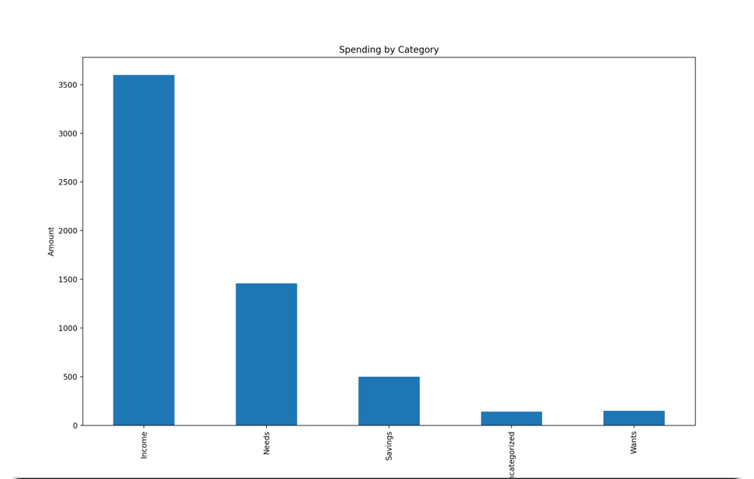
Figure 1: Distribution of spending across transaction categories (Income, Needs, Wants, and
Savings), with each bar representing the total monetary amount assigned to each category using
keyword classification.

The results show that the majority of expenditures are concentrated in specific categories (typically Needs and Wants), while Savings and Income form distinct financial inflows and allocations. This categorization provides insight into spending priorities and highlights areas where financial adjustments may be necessary. For example, a disproportionately large allocation to Wants may indicate discretionary overspending.
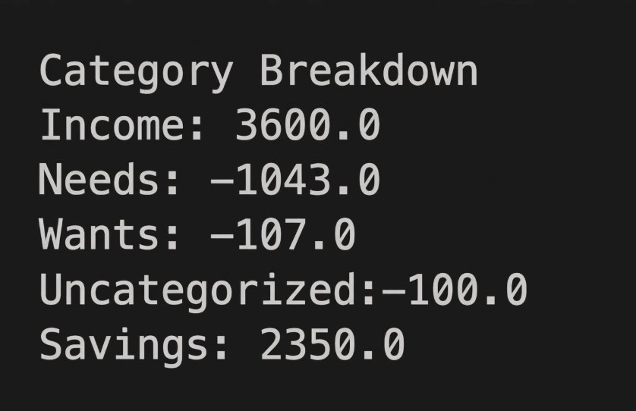
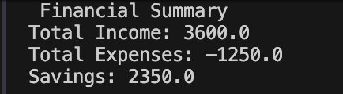
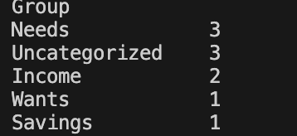

Statistical Analysis
Descriptive statistical measures were computed for the dataset, including the mean, standard deviation, and variance of transaction amounts. The mean represents the average spending per transaction, while the standard deviation and variance quantify the variability and dispersion of spending behavior.
A higher standard deviation indicates inconsistent spending patterns, suggesting the presence of irregular or impulsive expenses. In contrast, a lower standard deviation reflects more stable and predictable financial behavior. These statistical measures form the basis for subsequent probabilistic modeling and simulation.
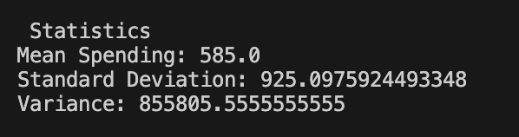

Time-Series and Calculus-Based Analysis
To analyze spending behavior over time, a time series was constructed by aggregating daily expenditures. This time-dependent representation, S(t), serves as the foundation for applying calculus-based methods (3).
Three key functions were derived and visualized (Figure 2):
- Spending over time S(t): represents the total amount spent on each date.
- Rate of change S′(t) (approximated numerically): calculated using discrete differences between consecutive days. This function identifies increases or decreases in spending.
- Cumulative spending: calculated using a cumulative sum, representing the total expenditure over time (numerical integral).
The derivative S′(t) provides insight into short-term behavioral changes. Large positive spikes indicate sudden increases in spending, while negative values indicate reductions. A threshold based on the standard deviation of the derivative was used to detect unusually large fluctuations. These spikes often correspond to irregular events such as large purchases or unexpected expenses.
The cumulative spending curve demonstrates the overall progression of expenditures relative to time. When compared to the user-defined budget, this curve allows for real-time assessment of whether spending is on track, approaching the limit, or exceeding it.

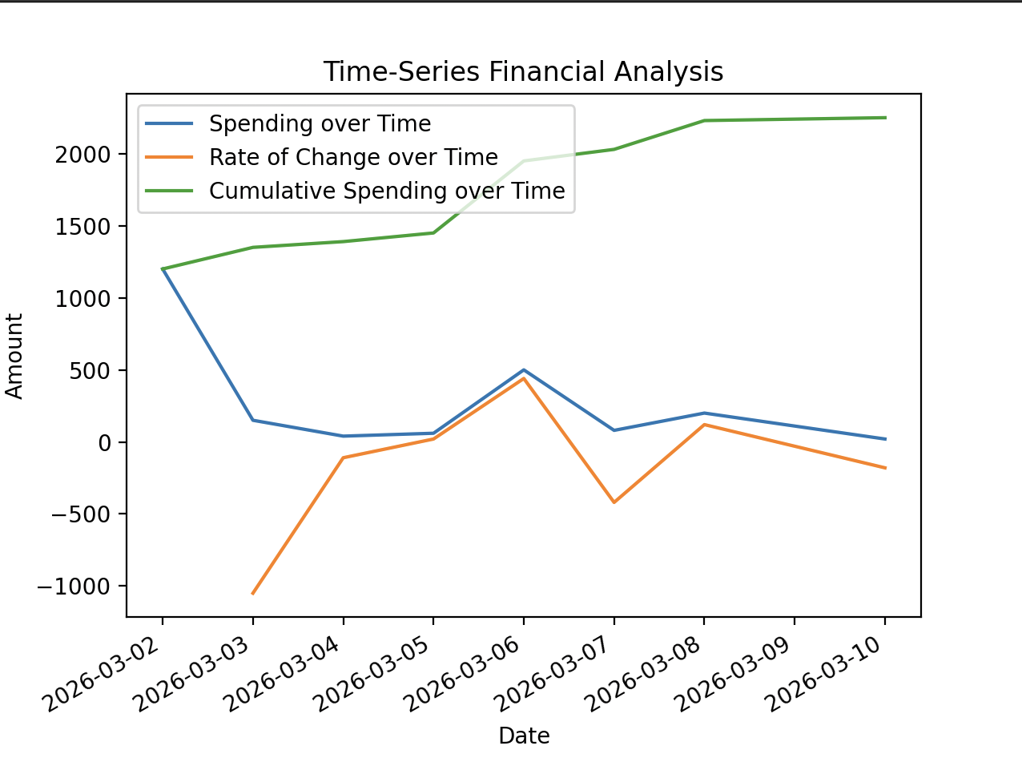
Figure 2: Time series financial analysis over from March 2nd, 2026 to March 10th, 2026,
including spending over time, rate of change over time, and cumulative spending over time.

Budget and Behavioral Analysis
Overall, by combining cumulative analysis, anomaly detection, and trend evaluation, the model provides a comprehensive understanding of financial behaviour, linking mathematical concepts such as integrals and derivatives to real-world spending patterns.
INPUT (User inputs budget) :
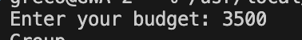
OUTPUT (Based on mathematical analysis) :
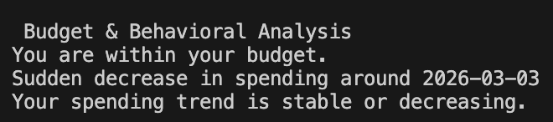

Monte Carlo Simulation and Probabilistic Forecasting
The results of the simulation are visualized using a histogram (Figure 3), which represents the distribution of total spending over a specified time horizon (e.g., 12 months). The horizontal axis represents the total spending over a given time period, while the vertical axis is the frequency of simulations for certain spending ranges. This distribution provides a probabilistic view of future financial outcomes rather than a single deterministic prediction. Along with the histogram, the average total spending is given, which provides the estimated spending for a given time period. The minimum and maximum spendings that occurred in any of the simulations are also given to be used as an uncertainty range.
From this distribution, it is possible to estimate:
- The likelihood of exceeding a given budget
- The expected range of future expenditures
- The variability and risk associated with spending behavior
The simulation results demonstrate that even if average spending appears manageable, variability can significantly impact long-term financial outcomes. This highlights the importance of accounting for uncertainty rather than relying solely on average values.
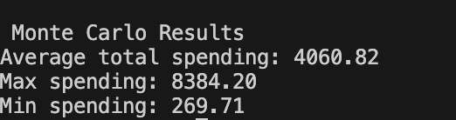
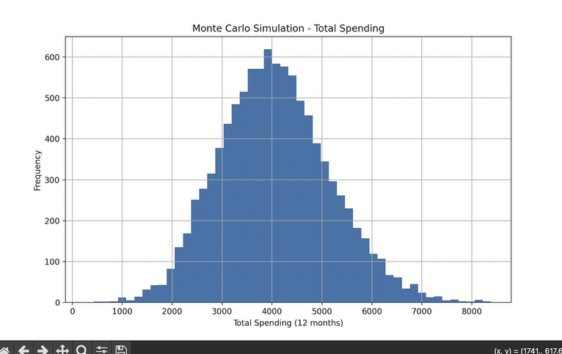
Figure 3: Monte Carlo Histogram of total projected spending over a 12 month time period
and 10,000 simulations, with each simulation drawing monthly spending values from a
normal distribution based on historical mean and standard deviation.

Discussion and Significance
Overall, the results demonstrate that combining statistical analysis, calculus-based modeling, and probabilistic simulation provides a comprehensive framework for understanding personal financial behavior. The use of derivatives enables detection of short-term fluctuations, while integrals (cumulative sums) provide long-term expenditure tracking. Monte Carlo simulation extends this analysis by incorporating uncertainty and generating realistic future scenarios.
The findings are consistent with principles in financial modeling and behavioral economics, where variability and uncertainty play a critical role in decision-making. However, several limitations should be noted. The assumption of normally distributed spending may not fully capture extreme or irregular expenses, and the accuracy of predictions depends heavily on the quality and quantity of input data. The normal distribution does not take into account irregular events that can skew the mean and standard deviation. Additionally, categorization based on keywords may introduce minor classification errors.
Despite these limitations, the model successfully demonstrates how mathematical and computational methods can be applied to real-world financial data to generate meaningful insights. It provides both descriptive and predictive capabilities, making it a valuable tool for analyzing spending habits and improving financial decision-making.

Conclusion
For our project, we made a Python program that uses a combination of calculus concepts and probability distributions to analyze personal spending and provide the users with financial risk assessment. The program uses the user-provided spending data, categorizes the expenses, and computes statistics, time-series trends, and cumulative totals. It can identify periods of time that have rapid change and surpass the budget by calculating the derivative of spending over time, while the cumulative sum, which is calculated using the integral, can track the total expenses. The Monte Carlo simulation addresses the inevitable uncertainty in personal finances by producing a range of possible outcomes that present the likelihood of exceeding a specific budget. This offers a nuanced perspective on the possible risks that are involved in financial budgeting.
However, there are certain limitations to this model that could be addressed. The use of normal distribution does not necessarily take extreme or irregular expenses into account. Furthermore, the expense categorization might misclassify certain transactions. A machine-learning model could increase accuracy.
Despite these limitations, the goals of this project were achieved, and it proves that mathematical modeling along with computational methods can be used for financial insight.

Guide To Use Program
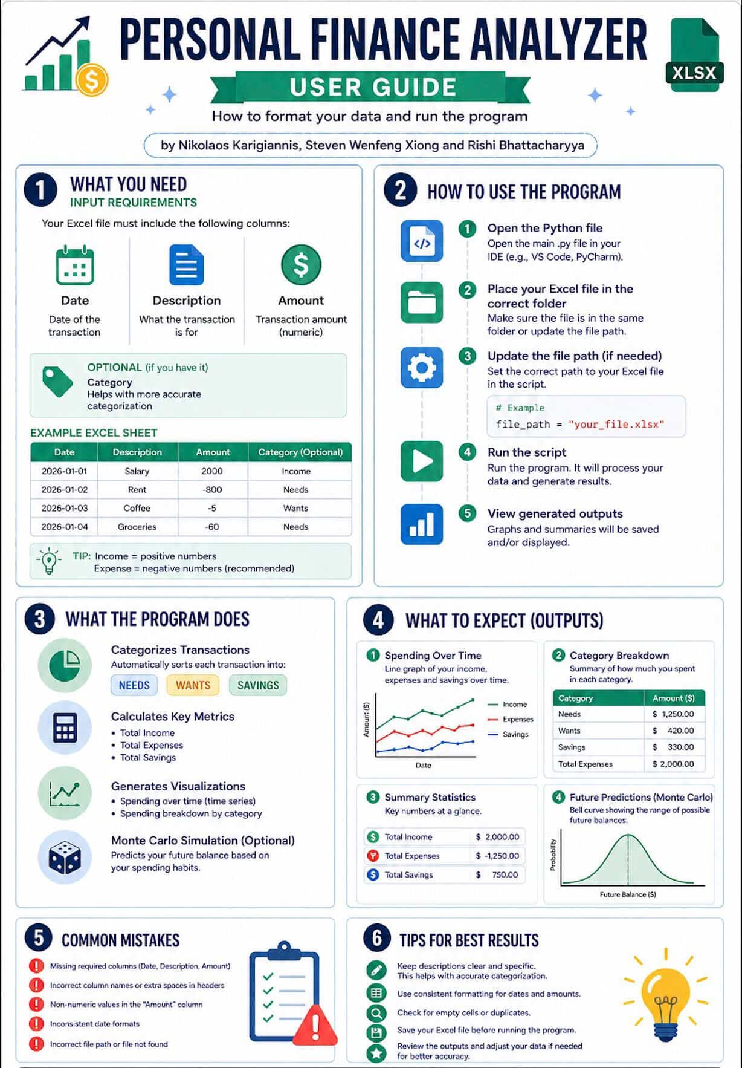

To use the program, the user begins by preparing an Excel file containing at minimum the columns Date, Description, and Amount (with optional categories if desired). This file is placed in the same directory as the Python script, or the file path is updated accordingly. When the program is executed, the user is prompted to input a personal budget, which is used as a benchmark for financial evaluation. The program then automatically cleans the data, formats values, and categorizes each transaction into groups such as Income, Needs, Wants, and Savings using keyword matching. It generates a structured dataset and summary tables showing total income, expenses, savings, and category breakdowns.

Next, the system performs time-series analysis, producing visualizations such as spending over time, rate of change (derivative), and cumulative spending (integral). It evaluates whether the user is within budget, close to exceeding it, or has already surpassed it, while also detecting unusual spikes or drops in spending behavior. Finally, the program runs a Monte Carlo simulation using the mean and standard deviation of past expenses to generate thousands of possible future spending scenarios. These results are displayed through summary statistics (average, minimum, and maximum spending) and a histogram, allowing the user to understand the range of possible outcomes and the risk of exceeding their budget. Overall, the program provides both descriptive and predictive insights with minimal user input.
This poster was done with the use of LLM, Canva and a bit of photoshop.

Final Code

import pandas as pd
import os
import matplotlib.pyplot as plt
import numpy as np
KEYWORDS = {
'Income': ['income', 'salary', 'allowance'],
'Needs': ['rent', 'bills', 'utilities', 'food', 'groceries', 'transport', 'insurance'],
'Wants': ['shopping', 'entertainment', 'restaurants', 'movies', 'subscriptions'],
'Savings': ['savings', 'investment']
}

file_path = "/Users/greco/Downloads/finance_test_data.xlsx"
def openexcel(file_path): #Function to open the excel file and combine all sheets into one dataframe
if not os.path.exists(file_path): #Checks if the file exists and if not it will show error message
raise FileNotFoundError(f"File Not Found: {file_path}")

data = pd.read_excel(file_path,sheet_name=None) #Reads all the sheets in the excel file and stores them in a dictionary
combined = pd.concat(data.values(), ignore_index=True) #merges all the sheets into one big dataframe

return combined

def categorize(df, description_column="Description"): #Function to categorize each transaction based specific keywords
df["Group"] = "Uncategorized"

for i, row in df.iterrows(): #Loops through each row of the dataframe
description = str(row[description_column]).lower() #Lowercase so that it matches the dictionary
for group, words in KEYWORDS.items():
for word in words:
if word in description: #If keyword is found it puts them in the correct category
df.at[i,"Group"] = group
break

if df.at[i,"Group"] != "Uncategorized":
break
return df

def positive(df):
df["Amount"] = df["Amount"].abs()
return df

def analyse(df, column="Amount"): #Function that analyzes income, expenses and savings (basic mathematics)
income = 0
expenses = 0

for i, row in df.iterrows(): #Goes through every row (loop)
amount = float(row[column]) #Turns the amount into float so that it can do mathematics with it (cant add and substract strings for math)
group = row["Group"] #Gets the category of the transaction

if group == "Income":
income += amount #Accumulates the income
else:
expenses += amount #If its not income its expense

savings = income - expenses #Savings is whatever you have left so income - expenses (incomes need to be positive of course)

print(" Financial Summary ")
print(f"Total Income: {income}")
print(f"Total Expenses: {expenses}")
print(f"Savings: {savings}")

def grouping(df, column="Amount"): #Function to show the total of each category and see where the big totals are coming from
totals = {} #open a dictionary

for i, row in df.iterrows(): #goes through every frame of the data frame
group = row["Group"] #gets the category of the transaction
amount = float(row[column]) #turns it into a float so that we can do math with it

if group in totals: #If the category already exists its add to the total, if it doesnt it makes a new entry
totals[group] += amount
else:
totals[group] = amount

print("\n Category Breakdown ")
for group, total in totals.items(): #goes through the totals dictionary and prints the total of each category
print(f"{group}: {total}")

def ArrangeTheData(df): #Function to clean the data and format everything to prevent crashes and errors
df = df.dropna(subset=["Amount", "Description"]) #Drops rows that have missing values in the Amount or Description columns

df["Amount"] = pd.to_numeric(df["Amount"], errors="coerce") #Convert all the amounts into numbers and if it is not a number it becomes NaN which means not a number and it gets disregarded
df = df.dropna(subset=["Amount"])

df["Description"] = df["Description"].astype(str).str.strip().str.lower() #cleans the description column so that it can match the dictionary keywords
if "Date" in df.columns: #checks for a date column and changes it into time frame format so we can use that for further analysis

df["Date"] = pd.to_datetime(df["Date"], errors="coerce")
df = df.dropna(subset=["Date"]) #removes rows with invalid dates
return df

def plotdifferentcategories(df): #function to plot the different categories
totals = df.groupby("Group")["Amount"].sum()

totals.plot(kind="bar")
plt.title("Spending by Category")
plt.xlabel("Category")
plt.ylabel("Amount")
plt.show()

def statistics(df): #function to calculate basic statistics
mean = df["Amount"].mean() #average
std = df["Amount"].std() #standard deviation (the spread of the data)
var = df["Amount"].var() #variance (spread squared)

print("\n Statistics ")
print(f"Mean Spending: {mean}")
print(f"Standard Deviation: {std}")
print(f"Variance: {var}")

return mean, std

def buildtimeseries(df): #function to build a time series (which is the spending over time)
df = df.sort_values("Date") #sorts data by date

daily = df.groupby("Date")["Amount"].sum()#groups all the data by date and adds the amounts

return daily

def derivatives(timeseries): #function to calculate the rate of change (derivative)
derivative = timeseries.diff() #diff is the difference between each value and the previous one (deriavtive)
return derivative

def integrals(timeseries): #function to calculate the cumulative spending (integral)
cumulative = timeseries.cumsum() #cumsum is cumulative sum which is the integral
return cumulative

def plottimeseries(ts, derivative, cumulative): #function to plot the last 3 functions which is time series, derivatives and the integrals
plt.figure()
ts.plot(label="Spending over Time") #original spending
derivative.plot(label="Rate of Change over Time") #change in spending
cumulative.plot(label="Cumulative Spending over Time") #total over time

plt.legend()
plt.title("Time-Series Financial Analysis")
plt.xlabel("Date")
plt.ylabel("Amount")
plt.show()
#BEHAVIORAL ANALYSIS
budget = float(input("Enter your budget: "))
def budgetbehavior(ts, derivative, cumulative, budget): #Function to analyze the budget and gives you insight on behavior
print("\n Budget & Behavioral Analysis ") #Prints the title

final_spending = cumulative.iloc[-1] #it gets the final cumulative spending which is the total spending at the end of the time series

if final_spending > budget: #If the spending is bigger than your budget (you have gone above)
print("You have exceeded your budget.")
elif final_spending > 0.8 * budget: #If you are close to your budget (more than 80%)
print("You are close to exceeding your budget.")
else:
print("You are within your budget.")

threshold = derivative.std() * 1.5 #It calculates a threshold that is considered a significant change

for i in range(1, len(derivative)): #it goes through all the derivatives (results of the rate of change) and checks for signifcant change
change = derivative.iloc[i] #gets the change
date = derivative.index[i]#gets the date of the change

if abs(change) > threshold: #if the change is bigger than the threshold its considered a signifcant change
if change > 0: #if its positive its a sudden increase, if negatgive its a sudden decrease
print(f"Sudden increase in spending around {date.date()}")
else:
print(f"Sudden decrease in spending around {date.date()}")

averagetrend = derivative.mean() #it calculates the average trend of the spending

if averagetrend > 0: #if positive it increases, if its negative it decreases
print("Your spending trend suggests you may exceed your budget in the future.")
else:
print("Your spending trend is stable or decreasing.")

#MONTECARLO SIMULATION
def montecarlo(df, months=12, simulations=10000): #function for montecarlo simulation, 12 months for 1 year and 10 0000 simulations (could add more to make it more accurate but it takes more time to run)

expenses = df[df["Group"] != "Income"].copy() #creates new data frame and only takes expenses and not income (df equals only stuff that isnt income so it only takes expenses)

expenses["Amount"] = expenses["Amount"].abs() #In the excel file expenses are negative but we have to make them positive so we take the absolute vaue (montecarlo doesnt work with negative values for this case)

mean = expenses["Amount"].mean() #calculates the mean
std = expenses["Amount"].std() #calculates standard deviation

results = [] #creates empty list

for _ in range(simulations): #loops through all the different simulations (10 000 times total)
total = 0 #sets total for every simluation to 0
for _ in range(months): #loops through each month (12 months because 12 in a year)
value = np.random.normal(mean, std) #picks a random number and sets it as the value (a normal number for the month that respects the normal distribution so it matches the mean and standard deviation)
total += max(value, 0) #adds the value to the total but if its negative it adds 0 so we avoid negative spending
results.append(total) #after 12 months it adds the total to the result list

return np.array(results) #turns the results into a numpy array so we can use calculations and plot with it

def plotmontecarlo(results):
plt.figure(figsize=(10,6))
plt.hist(results, bins=50) #plots histogram (this creates the bell curve)
plt.title("Monte Carlo Simulation - Total Spending")
plt.xlabel("Total Spending (12 months)")
plt.ylabel("Frequency")
plt.grid(True)
plt.show()

df = openexcel(file_path) #load excel data
df = ArrangeTheData(df) #clean and format the data
df = categorize(df, "Description") #categorize the data based on description and keywords
df = categorize(df, "Description")
df = positive(df)
print(df["Group"].value_counts()) #show how many transactions in ecah category
analyse(df, "Amount") #analyze all the data and show the summary
grouping(df, "Amount") #show the total of each category as an amount
mean, std = statistics(df) #Does the basic statistics
plotdifferentcategories(df) #plots the different categories (graph 1)
expenses_df = df[df["Group"] != "Income"].copy() #creates a new dataframe because we want to calculate only expeneses, if we put income it messes up the graph
expenses_df["Amount"] = expenses_df["Amount"].abs() #turns all the expenses that are negative in the excel into positives so that we can do the calculations
ts = buildtimeseries(expenses_df) #builds the time series of the expenses so that we can do calculations
derivative = derivatives(ts) #calculates the rate of change of the spending
cumulative = integrals(ts) #calculates the cumulative spending
plottimeseries(ts, derivative, cumulative) #plots the timeseries, derivatives and integrals
budgetbehavior(ts, derivative, cumulative, budget)#analyzes the budget and gives you insights on your behaviour
results = montecarlo(df) #defines results and runs the montecarlo simulation
#Run the Montecarlo simulation and print the results
print("\n Monte Carlo Results ")
print(f"Average total spending: {results.mean():.2f}")
print(f"Max spending: {results.max():.2f}")
print(f"Min spending: {results.min():.2f}")

plotmontecarlo(results)

Github: https://github.com/SleepGates/-Smart-Financial-Analyzer-

Works Cited
1. Hayhoe CR, Leach LJ, Turner PR, Bruin MJ, Lawrence FC. Differences in spending habits and credit use of college students. J Consum Aff. 2000;34(1):113-33. Available from: https://www.jstor.org/stable/23859984?seq=5

2. Merton RC. Influence of mathematical models in finance on practice: past, present and future. Philosophical Transactions: Physical Sciences and Engineering. 1994;347(1684):451-463. Available from: https://www.jstor.org/stable/54356?seq=1

3. Haugh M. A brief introduction to stochastic calculus. Columbia University; 2016. p. 1-7. Available from: https://www.columbia.edu/~mh2078/FoundationsFE/IntroStochCalc.pdf

4. Berman JZ, Tran ATK, Lynch JG, Zauberman G. Expense neglect in forecasting personal finances. Journal of Marketing Research. 2016;53(4):535-550. Available from: https://www.jstor.org/stable/44134930?read-now=1&seq=1#page_scan_tab_contents

5. Stoyanov J. Moment properties of probability distributions used in stochastic financial models. In: Muromachi Y, Shibata T, Kijima M, editors. Recent Advances in Financial Engineering - Proceedings of the TMU Finance Workshop 2014. Singapore: World Scientific; 2016. p. 1-27. Available from: https://d1wqtxts1xzle7.cloudfront.net/126012452/fulltext-libre.pdf?1767347377=&response-content-disposition=inline%3B+filename%3DMoment_Properties_of_Probability_Distrib.pdf&Expires=1771870912&Signature=b6cZ7xuVDwVEqxQbGIx~FWMUAPV9l1XLUblchqBlYmfZDo-DDHPs3ECVyXHESvA5W72p5XfH7xfeCTJ55kgn9scH13pr-nf065bCn0AA3Y11k5pJWvO7Vh3kSg8LsAE8dMf-AXrUblZeKYMj-1MJVvU1D3SFeZJ1T~F267ItAM93u4Rb0le3d9fBBX2yHuc~boxdcs7ocnvUTyUDUbc6QZODC4z9ET-gNEN~Ke-rpBMKi-Hzf7EsrLBsVHotyjO5w62J3ZpdquEbXmXHZwOF-zBVuOC83sH8hRPZ22KgNYchXFNIOtgBNJQnfXpSxgfFomonSYhM0A5qOVkCL~-TKg__&Key-Pair-Id=APKAJLOHF5GGSLRBV4ZA

6. Kritzman M. What practitioners need to know about Monte Carlo simulation. Financial Analysts Journal. 1993;49(6):17-20. Available from: https://www.jstor.org/stable/4479694?seq=3

Ethical Assessment Report
Our project is a Python financial analyzer that tracks spending, analyzes trends, and provides possible future outcomes using a Monte Carlo simulation. The ethical considerations involved in this design project include data privacy, user autonomy, and accessibility of the program.
The program processes personal financial data from the users' Excel file that may contain sensitive private information. However, all the computation takes place locally on the user’s computer. No data is uploaded to any sort of server or third-party. This minimizes any risk of data breaches as nobody other than the user has access to their financial data. Nevertheless, users still need to responsibly secure their files. The program does not implement any sort of security for the users, so it is entirely up to them to secure or delete the files afterwards if there are any privacy concerns.
The program’s keyword-based categorization, derivative calculation, and random distribution in the Monte Carlo simulation are fully disclosed in the paper and the code. The users can edit the keyword dictionary and change the Monte Carlo simulation parameters. This provides transparency so that the users can fully understand how the program reaches its conclusions. We explicitly stated that the normal distribution is not entirely accurate as it may not consider extreme expenses and that the results are possibilities rather than guarantees.
The program is open source and can run on any computer that has Python, which is free. This allows students with limited resources to be able to easily access this tour. However, many users might not be familiar with Python. To make it more accessible for these users, we add step-by-step comments on the code.
In conclusion, the ethical risks of this project are extremely low as it respects data privacy, provides full transparency on how it works, and is easily accessible. Despite all of this, users must use the program responsibly, but the design of the project minimizes risks.
Environmental Impact Assessment
The environmental impact of this project stems mainly from electricity consumption during development, testing, and when the users use it. Over the course of approximately, we used three computers which each used approximately 30W for an hour of coding. Assuming that each member worked on the project for 3 hours each week for 8 weeks, this results in a total of 72 hours. This translates to 2.16kWh. This does not account for the time used for writing the project, although it would be minimal compared as more energy is used during programming. Hydro-Quebec has stated that the average carbon intensity is 2.48 CO₂eq per kWh. This means that development emissions caused by our project were roughly 5.36g of CO₂, which is not a lot. Additionally, we stored the code on GitHub, which uses servers that consume electricity. However, it is unknown how much electricity GitHub uses individually, but it is likely not significant. The main way that this project can improve in terms of environmental impact is to optimize the Monte Carlo simulation to take less time. Overall, the project has an extremely minimal environmental impact.

